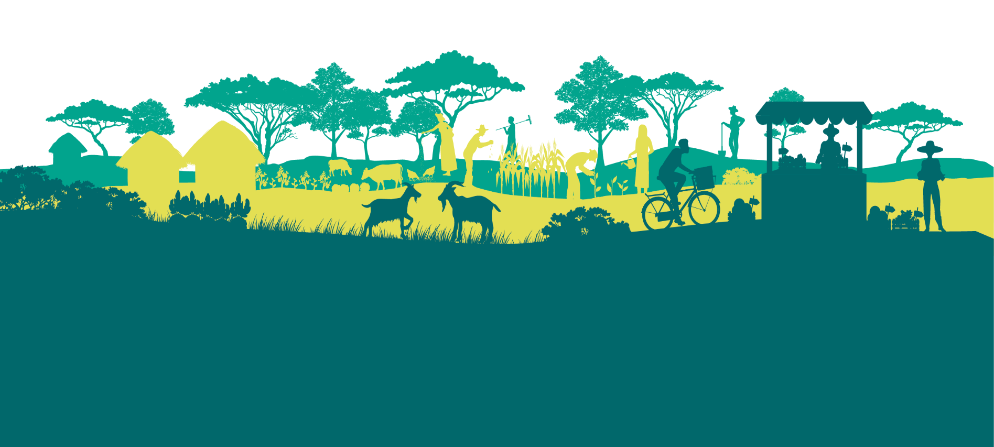



Application for Forum Membership of the
Agroecology Transformative Partnership Platform (TPP)

The TPP has three levels of membership:

- Partners are organisations that are formally engaged in AE-TPP projects (either integrated or aligned) and are active in the AE-TPP science-policy or development interface. Member organizations of the Agroecology TPP governance and advisory bodies are also automatically partners.

- Forum Members are organisations that have not entered into formal arrangements with the TPP but who are willing to support the application of the HLPE agroecological principles to transform food systems and the modalities outlined in the Membership Charter and TPP Concept note. They have also identified how their organisations can add-value to the TPP and how the TPP can add-value to their organisations. Forum Members can participate in an annual Members Forum event where they have the opportunity to participate in discussions and contribute their perspectives on TPP priorities.

- Individual CoP participants are people who join the GLFx Agroecology TPP Community of Practice (CoP) at: https://glfx.globallandscapesforum.org/topics/21467/page/TPP-home, where they can keep up to date with TPP activities and interact with others engaged with the TPP.

In order to apply for an organisation to become a Forum Member of the TPP, please complete the fields below and submit to the TPP secretariat. Completed applications will be considered for approval by the TPP Steering Committee and the outcome of the decision will be communicated after the next Steering Committee meeting (held quarterly).

Name and position:

Contact email address:

Organisation:

Organisation Address:
Please confirm that the nature of your organisation’s engagement with the TPP will be in line with the 13 HPLE agroecological principles and the modalities as laid out in the Agroecology TPP Membership Charter and Concept Note.

I confirm

Please describe briefly your organisation’s role or interest in research, education, or capacity building related to agroecological food systems transformation. Please also provide some information on the locations you are operating as well as some key agroecological projects you are currently involved in. Kindly also provide some activities you are conducting or plan to conduct related to agroecological research, education and capacity building.

Please indicate briefly how your organisation can add-value to the TPP:

Please indicate briefly how the TPP can add-value to your organisation:

Please confirm that you are willing to receive communications from the TPP.

I agree

Signed: Date:

The Secretariat can be reached via agroecology-tpp@cifor-icraf.org.
The TPP Membership Charter that can be found under ‘Resources’ on the TPP website here: https://glfx.globallandscapesforum.org/topics/21467/page/TPP-home
The TPP Concept Note that can be found under ‘Resources’ on the TPP website as well

